OD2-Unit5 知识清单
上课内容 | Unit5 Then and Now | 学习目标
单词1 | 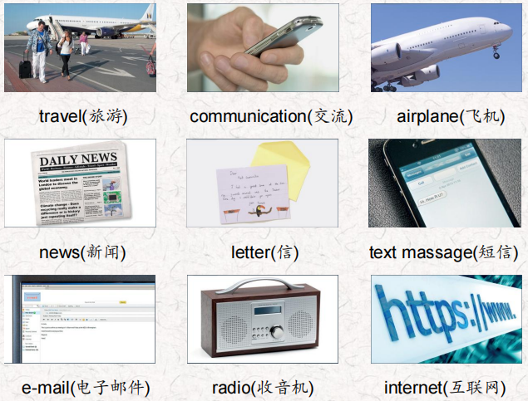 | 会听、会说、会读、会默写
短语 | all over the world 全世界  long time ago/ Long ago 很久以前  talk to与某人交谈  listen to 听。。。  by train 乘火车  by ship乘船 | 短语会造句
阅读技巧 | The main idea is what a text is about. There is one main idea. Other sentences in the text tell us more about the main idea. These are called details.  文章的主旨是关于什么的。有一个主要观点。文中的其他句子告诉我们更多关于主旨的信息。这些被称为细节。
重点句型 | But a long time ago things were very different.但在很久以前，情况却大不相同。  Long ago, people used letters to communicate. 很久以前，人们用信件来交流。  We can use e-mail, text messages, or phone calls to communicate quickly with friends and family all over the world.我们可以使用电子邮件、短信或电话与世界各地的朋友和家人快速沟通。  people talked to each other to get news.人们互相交谈以获取消息。  Later they listened to the radio for news.后来他们听收音机听新闻。  Today we can get news any time we want.今天，我们可以随时获得我们想要的新闻。  People long ago walked from place to place or traveled by horse and cart.很久以前，人们从一个地方步行到另一个地方，或者乘马车旅行。 When they traveled long distances they went by train or ship.当他们长途旅行时，他们乘火车或轮船。  Today we can travel in cars, fast trains, buses, or airplanes to go to places that are far way.今天，我们可以乘坐汽车、高速火车、公共汽车或飞机去很远的地方。
听力 | 听力词汇：  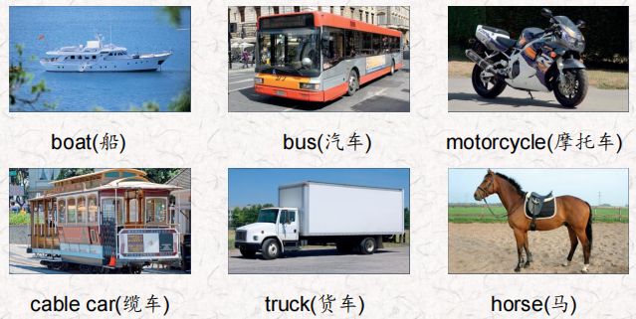  Look! They're delivering a lot of fruit and vegetables to the supermarket in that big truck. We didn't have trucks when l was a little girl.  What did you have then? Well, farmers delivered their fruit and vegetables to markets by horse and cart. lt was hard work and it was very slow. Really? I didn't know that. How did you go to school Grandma?  Well, we didn't go to school by bus back then. There weren't any buses! We traveled to school in cable cars. It was slow but it was fun.  There aren't any cable cars now. We go to school by bus now. Guess what, Grandma! Dad has a new motorcycle! Did people travel by motorcycle long ago? Oh, no! We didn't have motorcycles like people do now. We traveled to places nearby on bicycles. We didn't need a lot of money for a bicycle then. How did you travel when you wanted to go far away?  We didn't often go far away. But if we needed to go to another city, we traveled by boat on the river. It was slow and sometimes it was very cold. We never go by boat now. We travel by airplane. It's fast and fun. | 每天听+跟读
口语 | Asking for something to be repeated 要求重复某事  What country do you come from? 你是哪个国家的人?  Would you repeat that please? 请你再说一遍好吗?  Got it. Thanks.明白了。谢谢。
复述课文复述 | 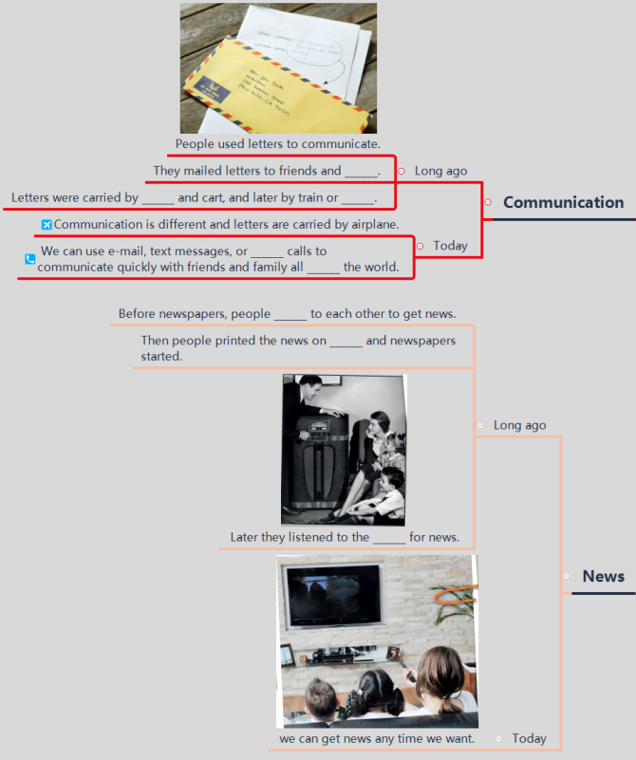  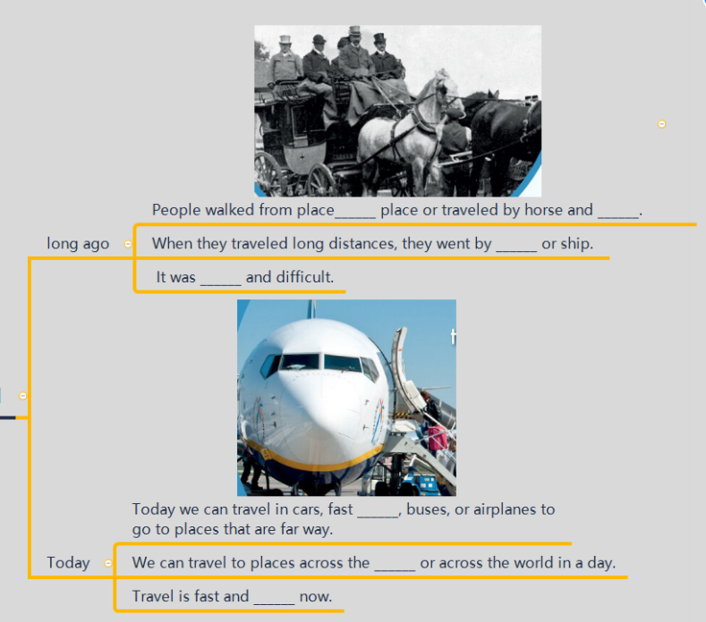 | 根据关键字提示复述课文复述
语法 | 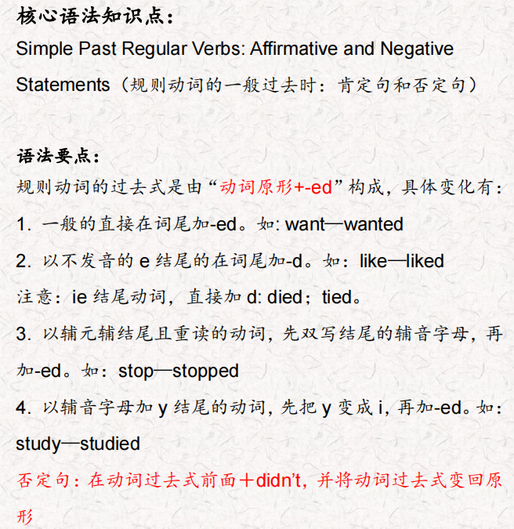
写作 | 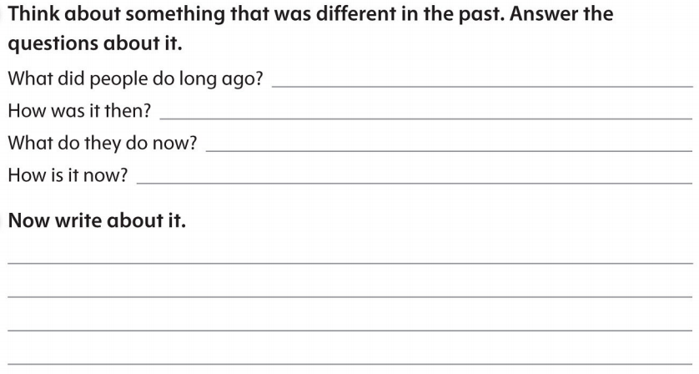 | 仿写

上课内容 | Unit6 Tell Me a Story, Grandpa | 学习目标
单词 | 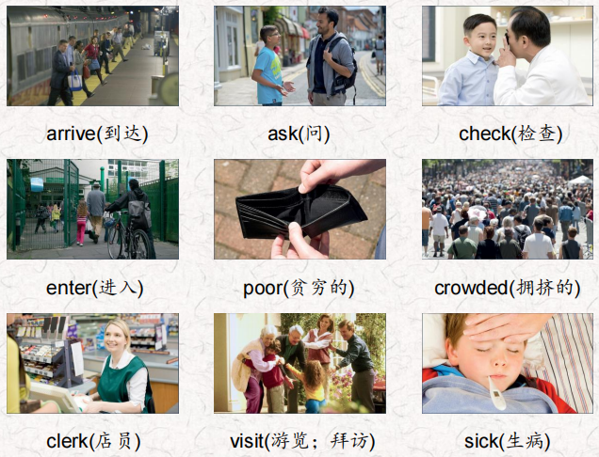 | 会听、会说、会读、会默写
短语 | a story about 关于什么的故事  the first time 第一次  get sick 生病  What happened？发生了什么？  take a trip to 去…旅行 | 短语会造句
阅读技巧 | Sequence is the order of things, such as 1, 2, 3, 4 or a, b, c, d. Stories often have a sequence. Events in a story happen in an order.  顺序是事物的顺序，比如1、2、3、4或a、b、c、d。故事通常有一个顺序。故事中的事件是按顺序发生的
重点句型 | I'll tell you a story about my grandfather, Carlo. 我要给你们讲一个关于我祖父卡罗的故事。  In 1910, Carlo was ten years old.1910年，卡洛十岁。  they came to the United States for a better life. 他们来到美国是为了过上更好的生活。  This was the first time that Carlo traveled to a place far away. 这是卡罗第一次到很远的地方旅行。  Mom, Dad, and I visit a different country every summer! 妈妈、爸爸和我每年夏天都会去一个不同的国家!  It wasn't an easy trip because the ship was crowded and dirty. 这不是一次轻松的旅行，因为船上又挤又脏。  There wasn't much food and many people got sick.没有多少食物，很多人生病了。  They arrived at Ellis Island in New York after ten days.十天后，他们到达了纽约的埃利斯岛  Now it only takes about nine hours in an airplane.现在坐飞机只需要9个小时。  What happened at Ellis Island?在埃利斯岛发生了什么?  Are you healthy or are you sick?你是健康还是生病?  Carlo was feeling better so they let him in. 卡洛感觉好多了，所以他们让他进来了  And that's why we live here today and not in Italy.这就是我们今天生活在这里而不是意大利的原因。  Let's take a trip to Italy.  我们去意大利旅行吧。
听力 | 听力词汇：  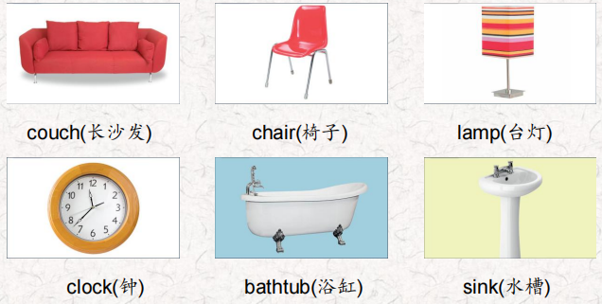  听力原文：  One.  Students, this is a great museum. We can see things that  people used a long time ago here.  Look at this. How do you turn it on?  You don't turn it on, There's a candle inside it.  A candle! How did they read at night a long time ago?  Most people didn't read at night, Emily!  Two.  Did people sit in that and wash, Ms. King? lt's very small Yes, they did, a very, very long time ago. That one is very very old.  Where did the water come from? They poured water in it from a big container, But first they heated the water!  Good!  Three.  Look at that! It's really small. And it's so plain!  Did students sit on them all day?  Yes, they did. Children were smaller a long time ago.  Really? I didn't know that.  Four.  Look at those numbers. They're very fancy.  Yes. They used those numbers a long, long time ago. Hey, I know what time it is. I can't read the numbers, but they're in the same place as the ones we have now.  Five.  Everything in here is small but look at that! lt's big. Yes, it is. People used it to wash their hands and face. But there was no hot water then.  I don't want to wash with cold water! I'm glad we have hot water now!  Six.  Look at that! It's small. Today they're big!  Yes. I fall asleep on ours sometimes!  Long ago two people could sit on that! And it wasn't long enough to sleep on.  I'm really happy I can sleep on mine! | 每天听+跟读
口语 | Describing travel and transport 描述旅行和交通  Where did you travel? 你去哪里旅行了?  I traveled to Washington.我去了华盛顿。  How did you travel there?你是怎么去那里旅行的?
复述课文 | 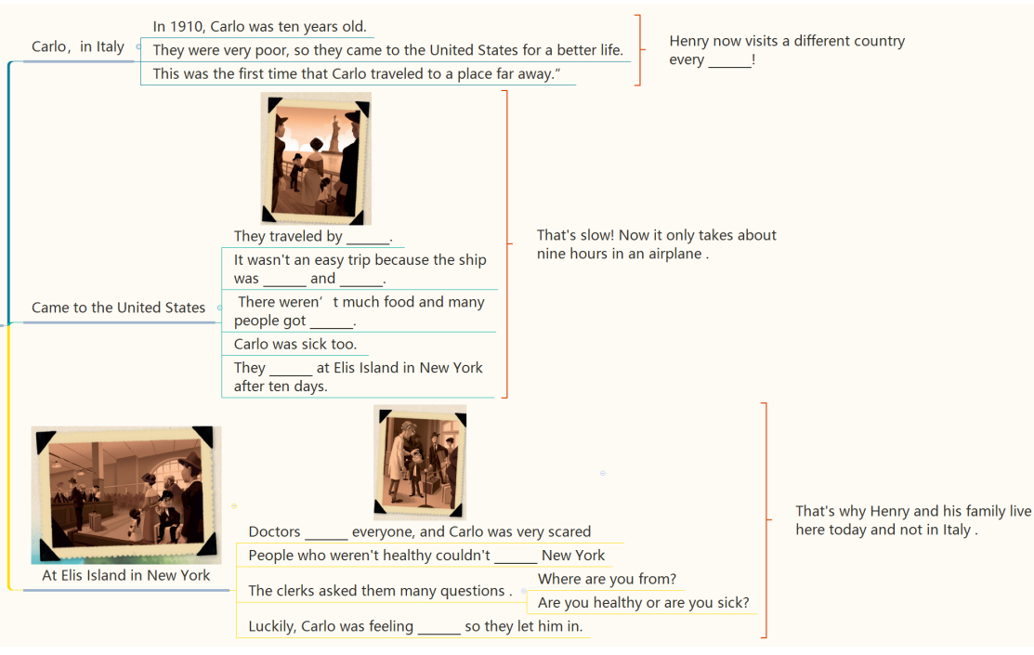 | 根据关键字提示复述课文复述
语法 | 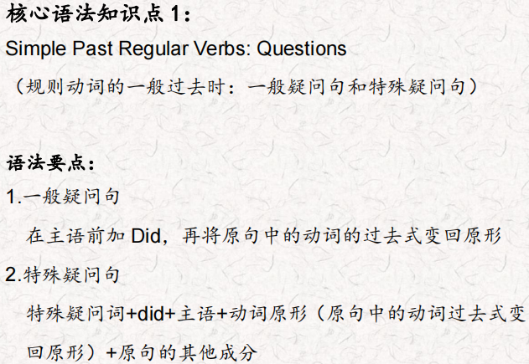
写作 | 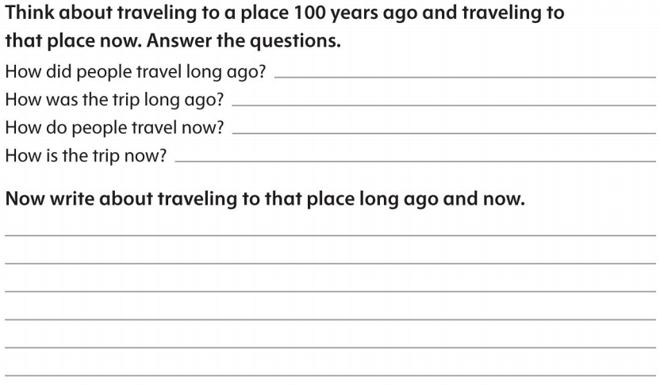 | 仿写

